**Online Diary –**

Groups Members – Connor Winspur, Saira Mahmood, Connor Hadley.

1. **- Overview and Game Description**

The task that was given to the team was to take a digital game and convert it into a physical board game. The game we chose to make into a board game was Call of Duty: Warzone. The idea behind the choice of game was to create a battle royal experience on a physical level. The board will be a large map with several players that will be randomly distributed through the map, the map will be made up of tiles that will have equipment cards distributed randomly across that will provide people with different types of attack or tactical options. The players will all have a character sheet that will contain information such as health, inventory space and armour. The goal is to be the last one standing.

**8.1 – Materials**

The game can be played using the provided board and cards, while utilising both a D-6 and D-20 die.

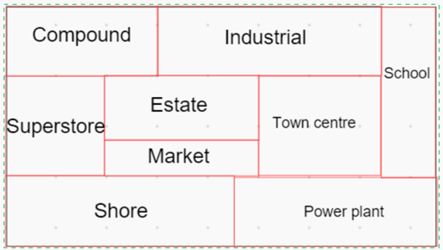

[A]

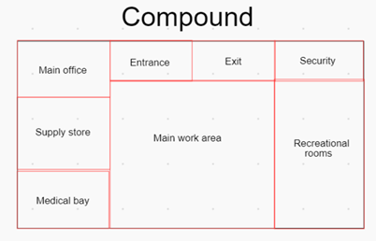

[B]

Figure 8.1 – Game Board

This figure shows the board the game will be played on. With [A] showing the full board, while [B] shows the layout if each section of the map.

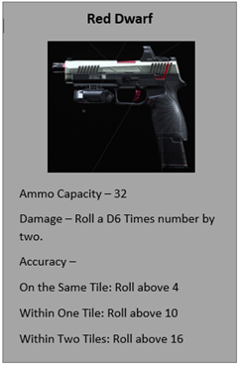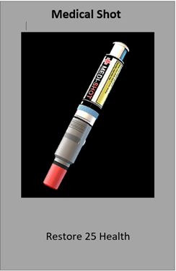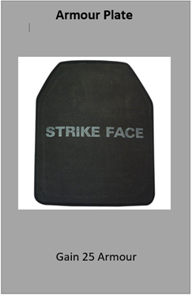

[C]

[B]

[A]

Figure 8.2 – Loot Cards

This scene shows examples of the cards that will be distributed across the tiles on the map. With [A] being a type of weapon, [B] being a health card and [C] being an armour card.

**8.2 – Rules and Mechanics**

During the development of the game idea the team looked at what the player would expect from a physical version of a game they have played. What was concluded was,

* PVP style gameplay.
* Travelling across the map.
* Tactical decision making.

What could be achieved from these expectations were,

* Travelling across the map controlled using dice rolls that allows the player to move from space to space throughout the varying terrains.
* Tactical decision as the players must select which equipment they take into fights as well as where they decide to move along the map and ultimately where they start a fight.
* Whilst a typical PVP would not be achievable within this particular type of game, there will still be PVP elements within the game, making use of the tactical equipment provided to the player.

It was decided that some elements and designs needed to be added in order to replicate the overall experience the player would get due to the difficulty of translating this type of game to a physical version. These were,

* Use of die rolls to randomise outcomes while using equipment and terrain effects to supplement this.
* Card deck to randomly distribute equipment, with rarer cards having less copies in the deck. To simulate the random looting system and encourage movement.
* Character sheet to allow players to track their health, armour and inventory.

**8.3 – Play Testing**

Playtesting was not achieved for two main reasons, the first being one of the team members needing to leave in the middle of the games development and the second being the group spent too much time changing the game before a prototype version could be made.

**8.4 – Experience and Skills Learnt**

It was found that the team worked well to overcome the problems faced during the session and managed to cover for the loss of members. The team shared a wide range of ideas, allowing for a game idea to be built quickly. However, to do better the group needs to build a version of the game that can be experienced before making major changes to the premise and balance of the game.